BOOKSTORE MANAGEMENT SYSTEM
Submitted by:
Name: Yashvi Rai
Registration Number: 26BCE11176
Programme: B.Tech
Branch: Computer Science and Engineering (Core)
Semester: I
Academic Year: 2026–27
PROJECT DOCUMENTATION
Subject: Introduction to Problem Solving and Programming
Programming Language: Python
Database: MySQL
Project Type: Menu-Driven Database Management Application

1. INTRODUCTION
The Bookstore Management System is a menu-driven software application developed using Python and MySQL to manage the basic operations of a bookstore.
The system provides a structured way to maintain information about books and customers, process sales transactions, update book stock, and generate useful reports.
Python is used to develop the application logic and provide interaction with the user, while MySQL is used to store and manage the data permanently.
The project demonstrates the practical application of programming concepts such as functions, conditional statements, loops, input validation, exception handling, modular programming, SQL queries, database connectivity, and CRUD operations.

2. PROBLEM STATEMENT
Managing bookstore records manually can become difficult when the number of books, customers, and sales transactions increases.
A bookstore needs to maintain accurate information about:
* Available books
* Book prices and quantities
* Authors and publishers
* Customer details
* Sales transactions
* Stock availability
* Sales and inventory statistics
The Bookstore Management System provides a computerized solution for these requirements by storing information in a MySQL database and providing a simple menu-driven Python interface.

3. OBJECTIVES
The main objectives of the project are:
1. To develop a simple computerized system for managing bookstore operations.
2. To maintain book records using a MySQL database.
3. To maintain customer information efficiently.
4. To process sales transactions and generate bills.
5. To automatically update book stock after a sale.
6. To provide search and update facilities.
7. To generate inventory and sales reports.
8. To identify books with low stock.
9. To display the best-selling books.
10. To demonstrate the integration of Python with MySQL.

4. TECHNOLOGIES USED
4.1 -> Python
Python is used to develop the application and implement the program logic.
The project uses concepts such as:
* Variables
* Input and output
* Conditional statements
* Loops
* Functions
* Exception handling
* Modular programming
* SQL queries through Python

4.2 -> MySQL
MySQL is used as the database management system.
It stores:
* Book records
* Customer records
* Sales records

4.3 ->MySQL Connector/Python
mysql-connector-python is used to establish a connection between the Python application and the MySQL database.

4.4 -> Python IDLE
Python IDLE is used to write, edit, and execute the Python source code.

4.5 ->MySQL Shell
MySQL Shell is used to create, inspect, and manage the database and its tables.

5. FUNCTIONAL MODULES
The system is divided into four major functional modules.

5.1-> BOOK MANAGEMENT
The Book Management module handles all operations related to books.
It provides the following functions:
* Add Book
* Update Book
* Delete Book
* Search Book
* Display All Books

Book information includes:
* Book ID
* Book Name
* Author
* Publisher
* Category
* Price
* Quantity
The module also prevents duplicate Book IDs and handles attempts to delete books that are associated with existing sales records.

5.2 ->CUSTOMER MANAGEMENT
The Customer Management module handles customer records.
It provides:
* Add Customer
* Update Customer
* Delete Customer
* Search Customer
* Display Customers

Customer information includes:
* Customer ID
* Customer Name
* Phone Number
* Email Address
The system checks whether a customer exists before performing operations that require an existing customer record.

5.3 -> SALES AND BILLING
The Sales and Billing module is responsible for processing bookstore purchases.
The sales process includes:
1. Entering the Customer ID.
2. Checking whether the customer exists.
3. Entering the Book ID.
4. Checking whether the book exists.
5. Displaying the book price and available stock.
6. Entering the required quantity.
7. Checking stock availability.
8. Calculating the total amount.
9. Recording the sale in the database.
10. Automatically reducing the book quantity.
11. Displaying the bill.
The system also maintains a sales history.

5.4 -> REPORTS
The Reports module provides useful information about bookstore operations.
It contains:
Inventory Report:
* Number of different book titles
* Total books currently in stock
* Total inventory value
Low Stock Report:
* Displays books whose available quantity is less than or equal to the defined low-stock level.
Sales Report:
* Total number of transactions
* Total books sold
* Total revenue
Best-Selling Books:
* Displays books according to the number of copies sold.

6. CRUD OPERATIONS
The project demonstrates CRUD operations.
CRUD stands for:
Create – Adding new records.
Read – Searching and displaying records.
Update – Modifying existing records.
Delete – Removing records.
These operations are implemented mainly for books and customers.
For example, the Book Management module allows the user to create, read, update, and delete book records.

7. PROJECT MODULE STRUCTURE
The project is divided into multiple Python files so that different responsibilities are handled separately.
main.py
->Contains the main menu and controls the overall flow of the application.
books.py
->Contains all functions related to book management.
customers.py
->Contains all functions related to customer management.
sales.py
->Contains functions for sales transactions, billing, stock reduction, and sales history.
reports.py
->Contains functions for generating inventory and sales-related reports.
validation.py
->Contains input validation functions used to validate user input.
database.py
->Contains the function responsible for connecting the Python application to the MySQL database.
database.sql
->Contains SQL commands required to create the database and tables.

8. DATABASE DESIGN
The project uses a MySQL database named:
bookstore
The database contains three main tables:
1. Books
2. Customers
3. Sales

8.1 -> BOOKS TABLE
The Books table stores information about books available in the bookstore.
Field: book_id
Data Type: INT
Description: Unique ID of the book

Field: book_name
Data Type: VARCHAR(100)
Description: Name of the book

Field: author
Data Type: VARCHAR(100)
Description: Author of the book

Field: publisher
Data Type: VARCHAR(100)
Description: Publisher name

Field: category
Data Type: VARCHAR(50)
Description: Book category

Field: price
Data Type: DECIMAL(10,2)
Description: Price of the book

Field: quantity
Data Type: INT
Description: Available stock

book_id is the primary key and is automatically generated.

8.2 -> CUSTOMERS TABLE
The Customers table stores customer information.
Field: customer_id
Data Type: INT
Description: Unique ID of the customer

Field: customer_name
Data Type: VARCHAR(100)
Description: Customer name

Field: phone
Data Type: VARCHAR(15)
Description: Customer phone number

Field: email
Data Type: VARCHAR(100)
Description: Customer email address

customer_id is the primary key and is automatically generated.

8.3 ->SALES TABLE
The Sales table stores completed sales transactions.

Field: sale_id
Data Type: INT
Description: Unique ID of the sale

Field: customer_id
Data Type: INT
Description: ID of the customer

Field: book_id
Data Type: INT
Description: ID of the purchased book

Field: quantity
Data Type: INT
Description: Number of copies sold

Field: total_amount
Data Type: DECIMAL(10,2)
Description: Total transaction amount

Field: sale_date
Data Type: DATE
Description: Date of the sale

sale_id is the primary key.
customer_id is a foreign key referencing the Customers table.
book_id is a foreign key referencing the Books table.

9. ENTITY RELATIONSHIP DIAGRAM
The database contains three entities: Books, Customers, and Sales.
The Sales table connects the Customers and Books tables.

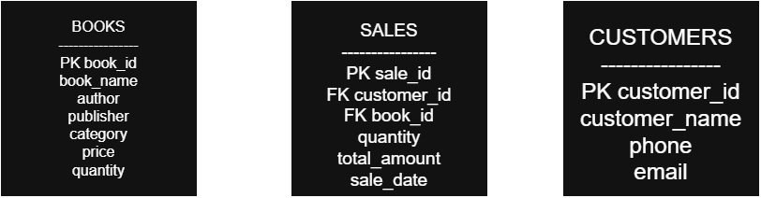
Relationship Explanation:
* One customer can have multiple sales transactions.
* One book can appear in multiple sales transactions.
* Each sale is associated with one customer and one book.
* customer_id connects Customers with Sales.
* book_id connects Books with Sales.

10. SYSTEM WORKFLOW

The overall workflow of the system is:
1. The program starts.
2. The main menu is displayed.
3. The user selects a module.
4. The selected module performs the required operation.
5. Data is retrieved from or stored in the MySQL database.
6. The result is displayed to the user.
7. The user can return to the main menu.
8. The program continues until the user selects Exit.
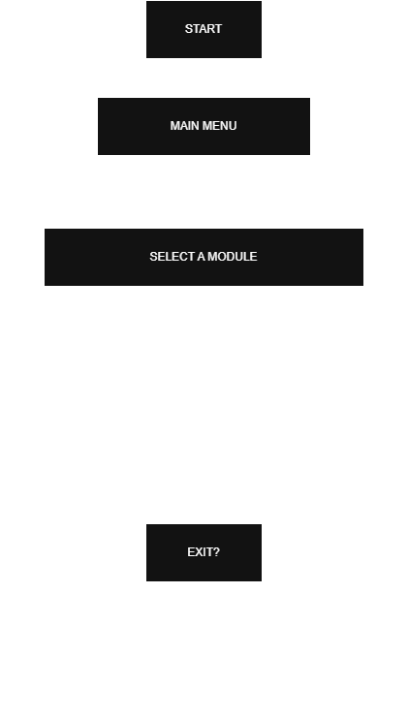

11. INPUT AND OUTPUT
11.1 -> INPUTS
The system accepts different types of input depending on the selected operation.
Examples include:
* Book ID
* Book name
* Author
* Publisher
* Category
* Price
* Quantity
* Customer ID
* Customer name
* Phone number
* Email address
* Search criteria
* Menu choices

11.2-> OUTPUTS
The system produces outputs such as:
* Book records
* Customer records
* Search results
* Updated records
* Bills
* Sales history
* Inventory reports
* Low-stock reports
* Sales reports
* Best-selling book reports

12. INPUT VALIDATION
Input validation is implemented to reduce invalid data entry.
The project includes validation for:
* Empty input
* Invalid integer values
* Invalid numeric values
* Negative values
* Duplicate Book IDs
* Duplicate Customer IDs
* Invalid quantities
* Insufficient stock
For example, when entering the quantity of books to purchase, the system checks that the quantity is greater than zero and does not exceed the available stock.

13. ERROR HANDLING
The project handles common errors to prevent the program from terminating unexpectedly.
Examples include:
Book Not Found:
If a user enters a Book ID that does not exist, the system displays an appropriate message.
Customer Not Found:
If a customer does not exist, the sale cannot be processed.
Insufficient Stock:
If the requested quantity is greater than the available quantity, the system rejects the sale.
Duplicate IDs:
The system checks whether a Book ID or Customer ID already exists before inserting a new record.
Foreign Key Restrictions:
A book or customer associated with an existing sale cannot simply be deleted because the sales record depends on it.
The system handles this situation and informs the user.

14. SALES PROCESS
The following steps are followed when a sale is made:
Customer Selection
The user enters the Customer ID and the system verifies that the customer exists.
↓
Book Selection
The user enters the Book ID and the system retrieves the book name, price, and available quantity.
↓
Quantity Entry
The user enters the required quantity.
↓
Stock Validation
The system checks whether sufficient stock is available.
↓
Bill Calculation
The total amount is calculated using:
Total Amount = Price × Quantity
↓
Database Update
The sale is recorded in the Sales table.
↓
Stock Update
The quantity of the book is reduced automatically.
↓
Bill Display
The system displays the Sale ID, customer name, book name, quantity, price, and total amount.

15. SAMPLE OUTPUTS
The following screenshots demonstrate the working of the project.
15.1-> MAIN MENU
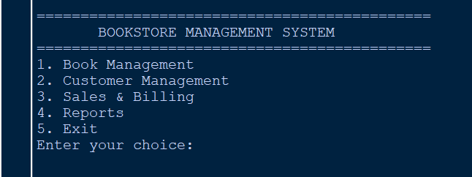

15.2 -> BOOK MANAGEMENT
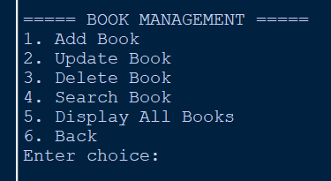
15.3-> CUSTOMER MANAGEMENT
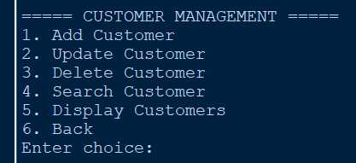
15.4 ->SALES AND BILLING
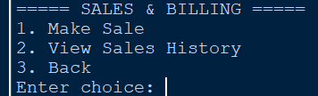
15.5-> INVENTORY REPORT
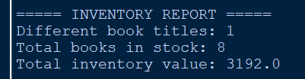
15.6-> SALES REPORT
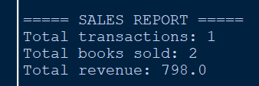
16. TESTING
The project was tested using different operations to verify that the system works correctly.
Test Case: Add a new book
Expected Result: Book is added to database
Status: Passed

Test Case: Add duplicate Book ID
Expected Result: Duplicate entry is rejected
Status: Passed

Test Case: Search for existing book
Expected Result: Book details are displayed
Status: Passed

Test Case: Update book
Expected Result: Book information is updated
Status: Passed

Test Case: Delete book with sales
Expected Result: Deletion is prevented
Status: Passed

Test Case: Add customer
Expected Result: Customer is added
Status: Passed

Test Case: Search customer
Expected Result: Customer details are displayed
Status: Passed

Test Case: Update customer
Expected Result: Customer information is updated
Status: Passed

Test Case: Make valid sale
Expected Result: Sale is recorded and bill displayed
Status: Passed

Test Case: Sell more than available stock
Expected Result: Sale is rejected
Status: Passed

Test Case: View sales history
Expected Result: Previous sales are displayed
Status: Passed

Test Case: Inventory report
Expected Result: Inventory information is displayed
Status: Passed

Test Case: Low-stock report
Expected Result: Low-stock books are displayed
Status: Passed

Test Case: Sales report
Expected Result: Sales statistics are displayed
Status: Passed

Test Case: Best-selling report
Expected Result: Books are listed by copies sold
Status: Passed

17. ADVANTAGES OF THE SYSTEM
The system provides several advantages:
* Reduces manual record keeping.
* Makes book searching easier.
* Maintains customer information systematically.
* Automatically updates stock after sales.
* Reduces errors during calculations.
* Provides quick access to sales information.
* Generates useful reports.
* Separates different functionalities into modules.
* Stores information permanently using a database.

18. FUTURE ENHANCEMENTS
The project can be further improved by adding features such as:
* User login and authentication.
* Multiple employee accounts.
* Advanced search filters.
* Discount and tax calculation.
* Invoice printing.
* Graphical user interface.
* Online payment integration.
* Supplier management.
* Automatic backup of database records.
* More detailed sales analytics.

19. CONCLUSION
The Bookstore Management System successfully demonstrates how Python can be integrated with MySQL to develop a practical database-driven application. The project provides separate modules for book management, customer management, sales and billing, and report generation. It also demonstrates important programming concepts such as functions, conditional statements, loops, input validation, exception handling, modular programming, SQL queries, and database connectivity.
The system provides a simple and organized way to manage bookstore records while reducing manual effort and improving accessibility of information.
Through this project, the concepts learned in Python and problem solving can be applied to a practical real-world management system.

